**LAB:  
NAME: K. MAYURI   
REG NO: 192372104**

**How to create a clone in github step by step:**

**Step 1: Go to github and create a repository**



**Step2: Click the code option**

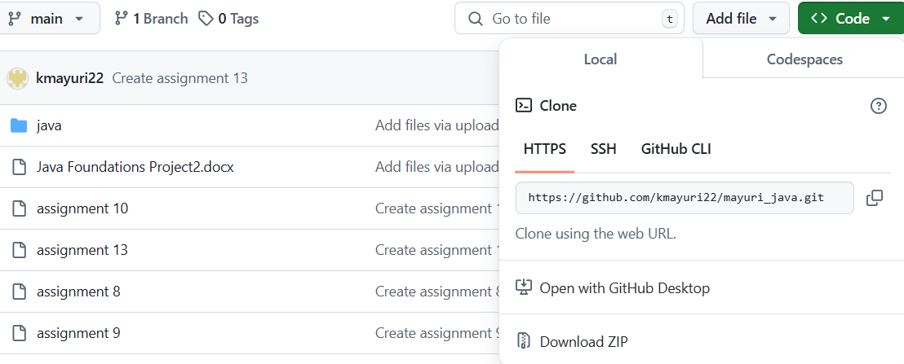

**Step3: Copy the clone url**

1.if you click the code it will show the options like https,SSH,Github

2.Copy the url of https

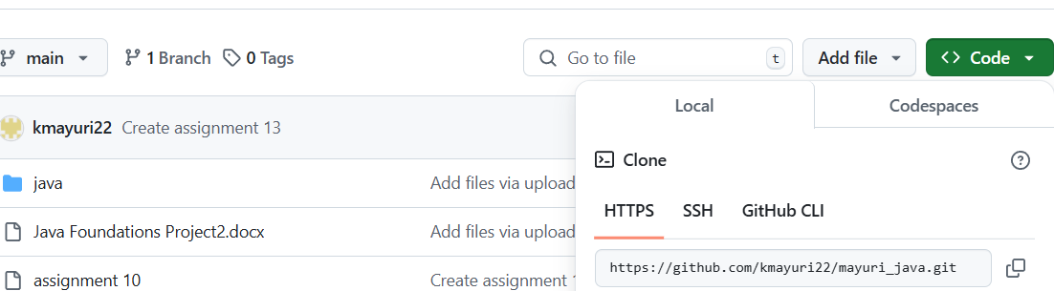

**Step 4: Open your files**

1. Open your files and create a new folder called sample
2. Download a Gitbash app

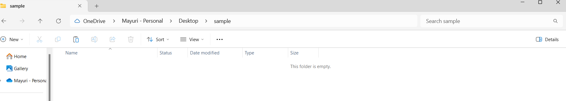

**Step 5: Click on the sample**



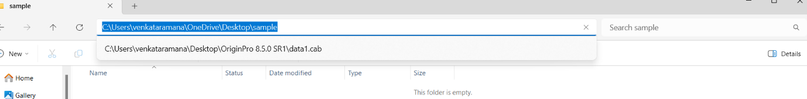

**Step 6: Copy the C:\sample and open the gitbash**

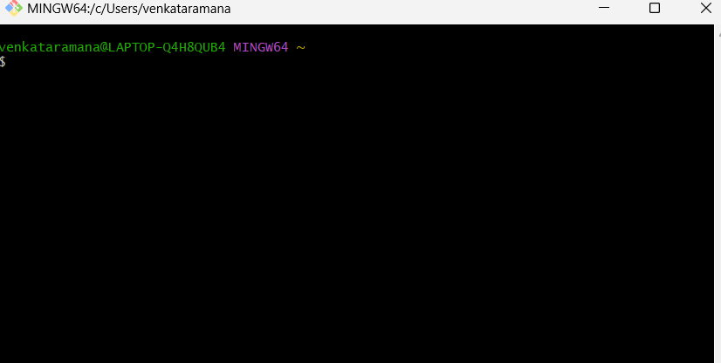

**Step 7: Type cd and paste the sample code “C:\sample ” and press enter**

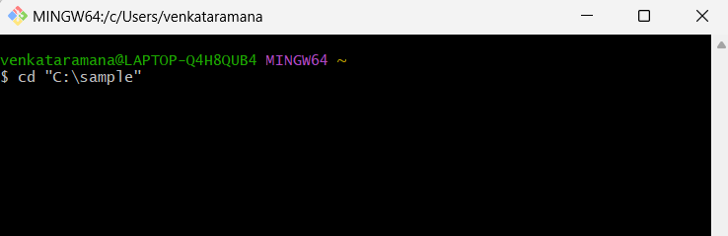

**Step 8: Type git clone and paste the https code and press enter**

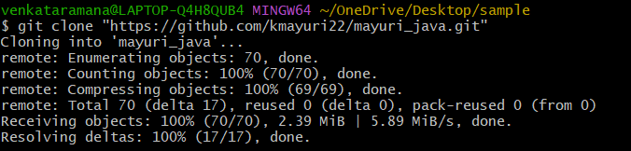

**Step 9: Type ls**

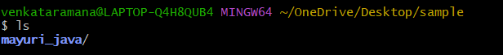

Step 10: Go the files and press sample 2

